**-**



**GOVERNMENT ARTS AND SCIENCE COLLEGE**

**PAPPIREDDIPATTI**

**DEPARTMENT OF MATHETICS**

# NAAN MUDHALVAN ONLINE COURSE

**TEAM LEADER NAME**

**KARTHICKRAJA E**

**PROJECT NAME**

**Unlocking Insights Into The Global Air Transportation Network**

## FACULTY NAME

**Dr. P. Raja., M.Sc., B.Ed., M.Phil., Ph.D.,**

**TEAM DETAILS:**

|  |  |  |  |
| --- | --- | --- | --- |
| **S.NO** | **NAME** | **USER NAME** | **POSITION** |
| **1** | **KARTHICKRAJA E** | **45FA9A97A886596802C4C34F6C486725** | **LEADER** |
| **2** | **MUGUNTAN P** | **B4663A6D18737BFBDBD405D1B279A060** | **MEMBER** |
| **3** | **POOVARASAN K** | **91B58A22B7CE78B8D014520618C6EA36** | **MEMBER** |
| **4** | **PRASANTHKUMAR C** | **B10B91E21154ECC8BF14226D9A9ABD0C** | **MEMBER** |

**TABLE CONTENT**

1. **INTRODUCTION**

* 1. Overview
  2. Purpose

1. **PROBLEM DEFINITION & DESIGN THINKING** 
   1. Empathy Map
   2. Ideation & Brainstorming Map
2. **RESULT**

1. **ADVANTAGES & DISADVANTAGES**

1. **APPLICATIONS**

1. **CONCLUSION**

1. **FUTURE SCOPE**

1. **APPENDIX**

# 1 INTRODUCTION

## 1.1 Overview

The air transportation network is a

complex network which has the properties of smallworld networks and scale-free networks. The degree distribution of the nodes displays a heavy-tailed distribution.

The air transportation system generally includes airports, ATS (air traffic control) system, and airlines. The airports represent the ground part of the system’s infrastructure handling the aircraft operated by different airlines transporting passengers and freight/cargo shipments.

## 1.2 Purpose

The worldwide air transportation network is responsible for the mobility of millions of people every day. Air transport allows people from different countries to cross international boundaries and travel other countries for personal, business, medical, and tourism purposes.

# 2. PROBLEM DEFINITION & DESIGN THINKING

## 2.1 Empathy Map

The airline could integrate empathy

into its dealings with employees and customers by providing additional training and support to its staff to help them better understand and respond to customer needs.

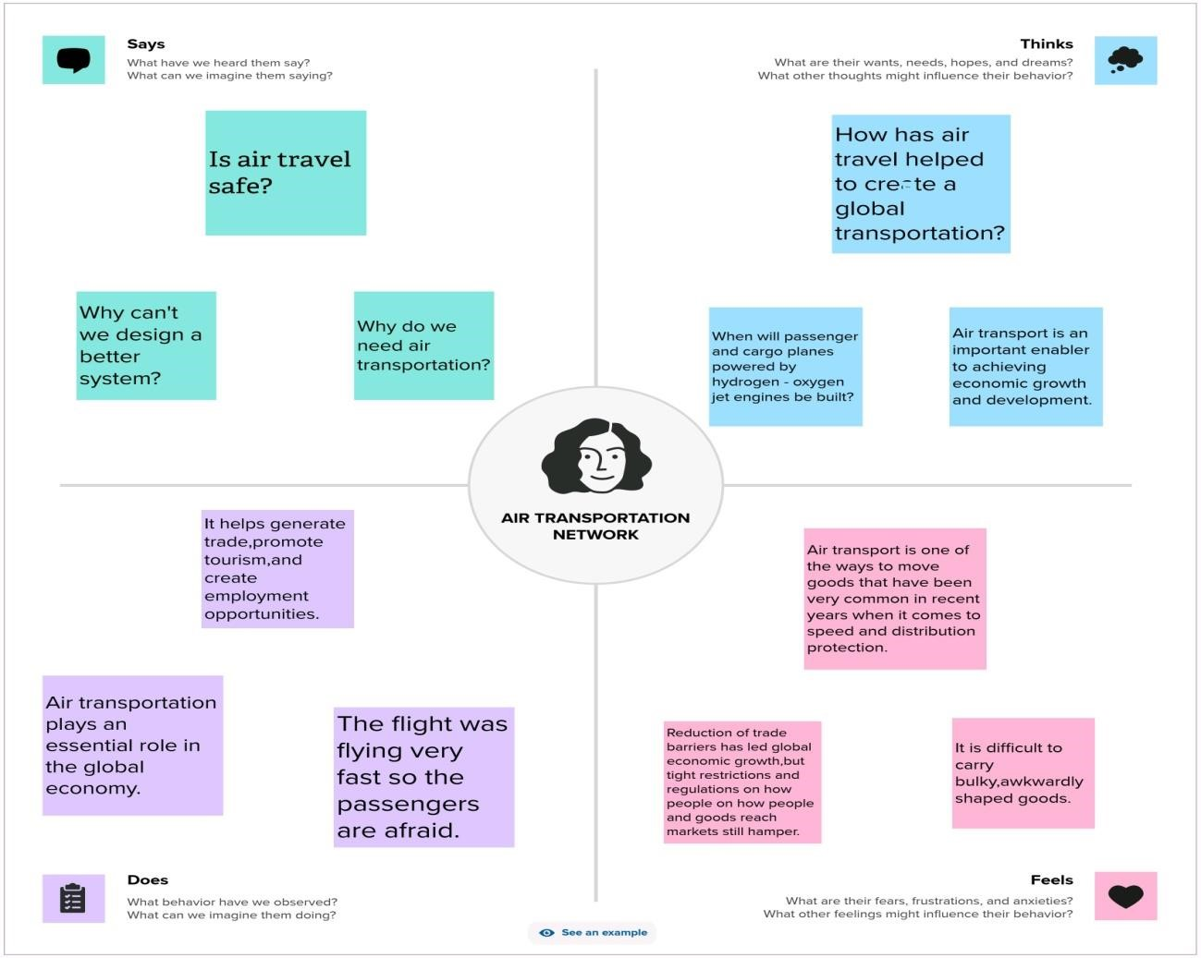

### 2.2 Ideation & Brainstorming Map

Brainstorming is the most common and the

most popular ideation technique in almost every industry. The intention of brainstorming is to leverage the collective thinking of the group, by engaging with each other, listening, and building on other ideas.

The importance of air transport lies in its ability as an economic engine to generate and support jobs, strengthen trade and connectivity between people and countries, promote tourism, and connect remote communities.

It highlights the significant difference in

emissions between air travel and ground transportation. The environmental impact of using AI systems, like any technology, depends on various factors, including the energy source used, the efficiency of the hardware, and the benefits derived from their use.

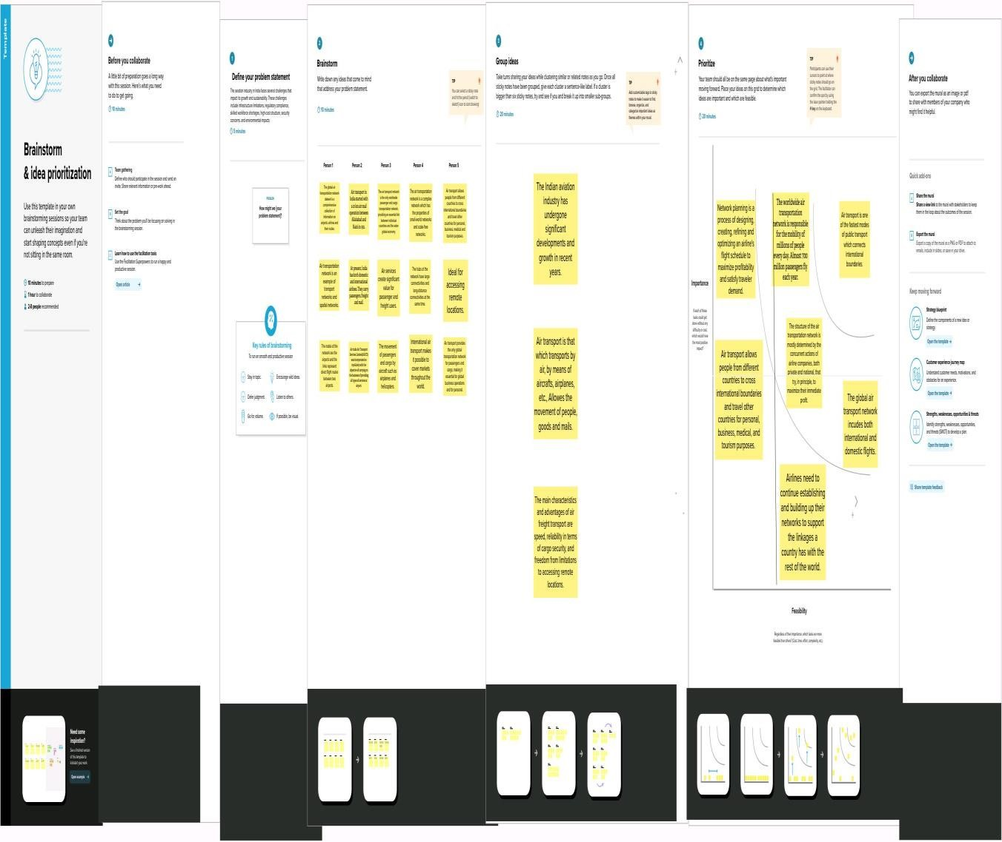

# 3. Results

A word class reputation developed through supporting clients with the acquisition, disposal or refinancing of aviation related assets. Air transport is one of the fastest modes of travel. Aeroplanes can carry people, mail and lightweight goods to distant places in

the shortest time possible.

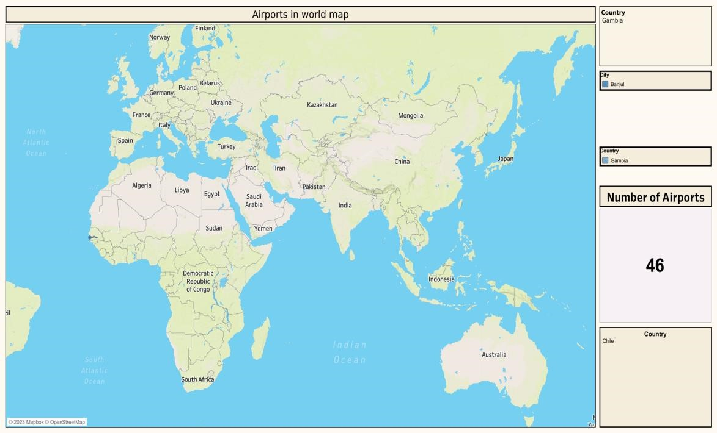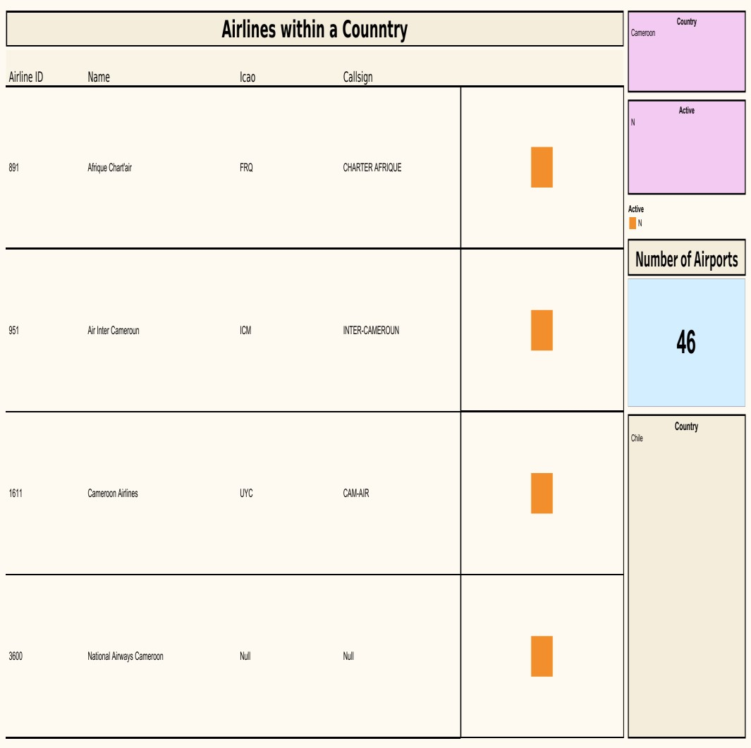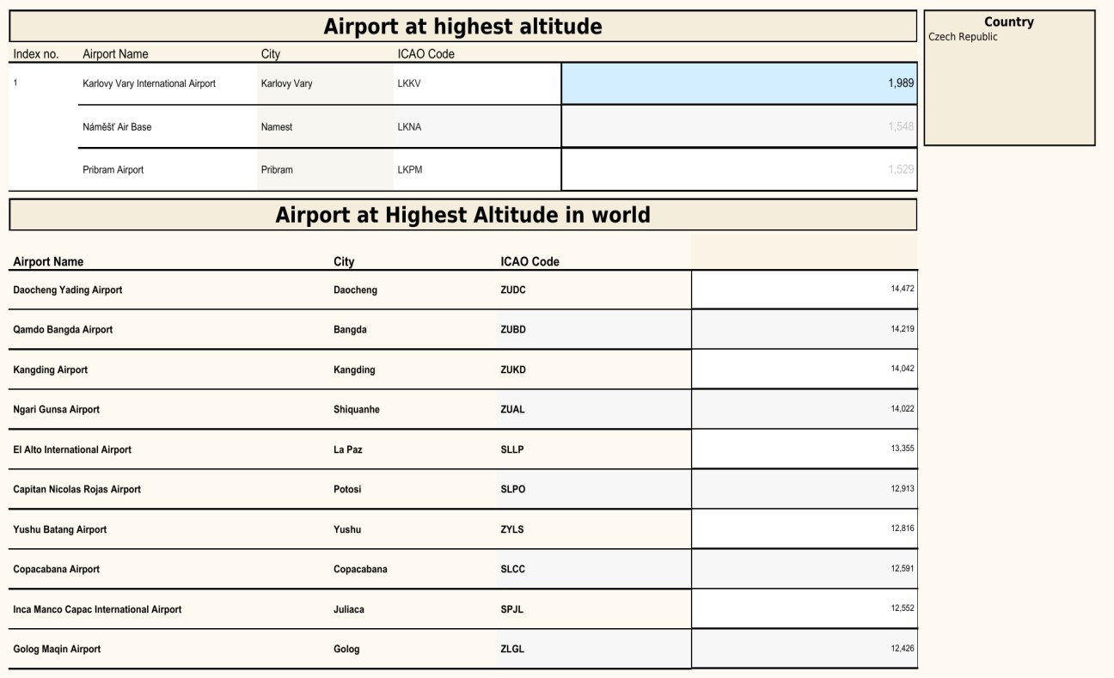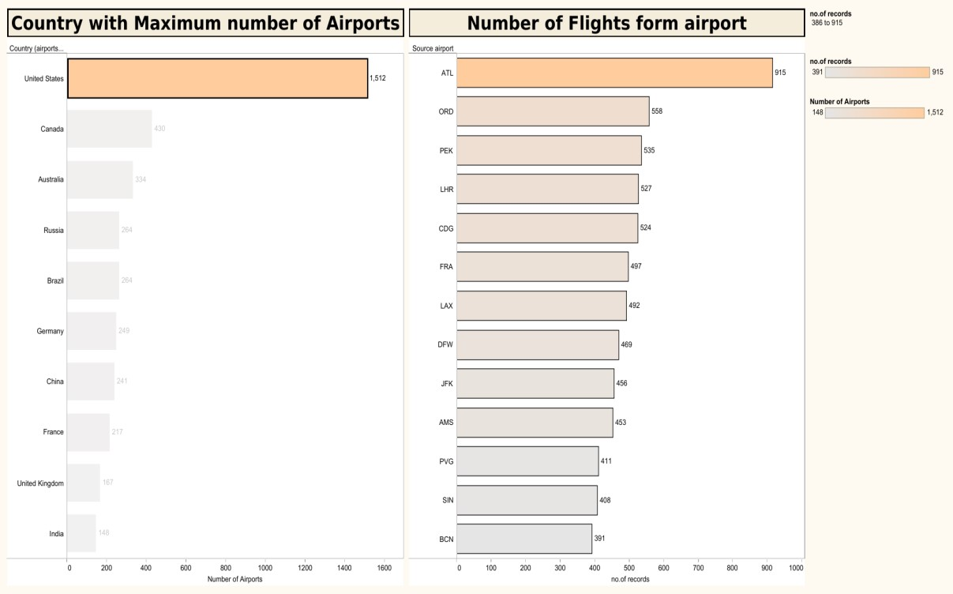

# 4. ADVANTAGES & DISADVANTAGES

Advantages:

1. **High Speed:** Air is the type of freight capable of travelling long distances in short periods of time. This makes this model an optimum choice if the client has an urgent need to ship a product or if their freight demands special standards of protection or acclimation. It is the quickest transport mode and is therefore ideal for longdistance transport of goods. It takes less time.
2. **Fast Service:** Air transportation offers convenient, reliable and fast services of transport. It is considered the cheapest way to ship peregrinated goods. It offers a standard, convenient, reliable and fast service.
3. **There is less need for heavy packaging:** Air exports, in general, entail less hard packaging than ocean shipments. This ensures you save both time and money by not having to provide extra packaging services.

## 4. Send almost everywhere your freight: In

regions that are not readily accessible to other modes of transport, air transport is considered to be the only means of transport. Open to all regions, irrespective of land interference. A vast network of airlines covering nearly the whole globe is available for many airlines. This ensures that the package can be sent almost anywhere.

1. **High Standard of Security:** High standard of protection with a low risk of robbery and injury. Shipping by air has a high degree of security since airport safety restrictions on cargo are strictly enforced. Tightly controlled airport controls also minimize cargo theft and loss.
2. **Natural Route:** An aircraft can fly to any location without seeing any natural obstacles or barriers. Since customs formalities are easily complied. It eliminates the need for more time to seek clearance. Air travel is used for relief operations during earthquakes, floods, accidents, and famines.

**Disadvantages:**

1. **Risky:** Air travel is the riskiest mode of transport, since there can be considerable losses to goods, customers and crews as a result of a minor crash. Compared to other means of travel, the risks of collisions are higher.
2. **Cost:** Air travel is considered to be the most expensive means of transportation. The cost of maintaining aircraft is higher and the costs for the building of aerodromes and avions are much higher. That’s why air travel is so expensive that it gets beyond ordinary people’s grasp.

## 3. Some Product Limitation: There is a whole

variety of materials not suitable for such products, from explosive, gases, batteries, fired solids and liquids, which cannot be shipped by air to name but a few.

1. **Capacity for Small Carriage:** The aircraft have no room and therefore are not ideal for carriage of voluminous and cheaper materials. As is seen for rails, the load volume cannot be raised.
2. **Enormous Investment:** Air travel calls for enormous spending in aerodrome building and servicing. It also calls for professional, qualified and qualified staff that needs a significant investment.

# 5. APPLICATIONS

* The air transport network is a global system of flight operations, connecting thousands of different destinations through both direct services and services via major hub airports. Air transport provides benefits by allowing people and goods to travel from A to B.

* Air transport allows people from different countries to cross international boundaries and travel other countries for personal, business, medical, and tourism purposes.

* By facilitating tourism and trade, it generates economic growth, provides jobs, increases revenues from taxes, and fosters the conservation of protected areas.
* Air transport is an important enabler to achieving economic growth and development. Air transport facilitates integration into the global economy and provides vital connectivity on a national, regional, and international scale. It helps generate trade, promote tourism, and create employment opportunities.

* Airways are one of the most comfortable and fastest modes of transportation. High mountains, deserts, and dense forests are made accessible by air transport. Air transport was nationalized in 1953.

* Aviation is the safest and fastest means of transportation, overcoming oceans and borders to connect people and support economic growth. It facilities tourism, trade provide jobs, provides a lifeline for remote communities and enables a rapid response when disasters when disasters occur.

# 6. CONCLUSION

The air transport industry is not only a

vital engine of global socio-economic growth but is also of vital importance as a catalyst for economic development in most countries and for many regions within each country. Air freight is a fast, flexible, and efficient shipping method that provides business with numerous benefits, including speed, flexibility, efficiency, and reduced risk of damage or loss.

In conclusion, the Indian aviation industry has undergone significant developments and growth in recent years. The expansion of regional connectivity, emergence of low-cost carriers, increased investment in infrastructure, and adoption of technological advancements have all contributed to the growth of the industry. In conclusion, considering the dangers associated with

negligence of flight security measures, all crewmembers must ensure they strictly adhere to the set safety rules, it being the only primary way of minimizing accidents.

# 7. FUTURE SCOPE

The most recent estimates suggest

that demand for air transport will increase by an average of 4.3% per annum over the next 20 years. If this growth path is achieved by 2036 the air transport industry will then contribute 15.5 million in direct jobs and $1.5 trillion of GDP to the world economy.

The roadmap outlined significant benchmarks to achieve the goal of making India the best-performing centre for aviation by 2040, in addition to expanding the country’s aviation industry. The aviation market is anticipated to expand quickly between 2022 and 2029 throughout the anticipated time period.

The forecasts of the vision 2040

document are: The document estimates that India will need 200 airports and an investment of $40-50 billion to handle at least 1.1 billion passengers flying to, from and within the country.

In the next 5 years, the Indian aviation industry s projected to see Rs 1 lakh crore ($ 15.52 billion) worth of investments, according to data published by the Department of Industrial Policy and Propaganda (DIPP), by the Government of India.

# 8. APPENDIX

<https://drive.google.com/drive/folders/1RJnbcGxvIVulM3fkZH1Wz3_IbLDP2RjY?usp=share_link>